Ms. Ashtekar Ankita Mahendra  Assistant Professor  Campus Address:  SDSS, Annasaheb Dange College of B Pharmacy (Diploma course), Ashta  Tal. Walwa, Dist. Sangli (416301)  Phone: Office: 02342-241124  Cell No. 9373816858  E-mail: ashtekar.ankitaadcbp@gmail.com |  |  | 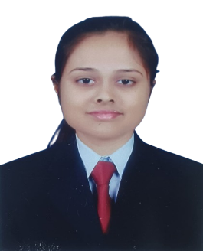
Education:
M. Pharmacy (2023-24) Appasaheb Birnale College of Pharmacy, Sangli
B. Pharmacy (2021-22) Annasaheb Dange College of Pharmacy, Ashta

Professional Work Experience:
Teaching | Research | Industry |  | Total
- | - | - |  | -
Professional Affiliations: Registered Pharmacist (Registration no. 364330)
Subject Taught: Diploma-
Research Foci. “Behavioral & biochemical evidences for antidepressant activity of Bauhinia racemosa leaves extract in mice exposed
to chronic unpredictable mild stress”
Number of Research Projects: 01 |  |  | Grants Received: Rs. -
Number of Publications: |  |  | Resource Person Presentations: -
Patent: -
Book Published: -
Selected Publications: -

