Ms. Ashwini S. Patil., M. Pharm.  Assistant Professor  Campus Address:  Sant Dnyaneshwar Sikshan Sanstha’s  Annasaheb Dange College of B Pharmacy  Ashta, Tal. Walwa, Dist. Sangli (416301)  Phone: Office: 02342-241125,  Cell No. 9654681806  E-mail: patil.ashwiniadcbp@gmail.com |  |  | 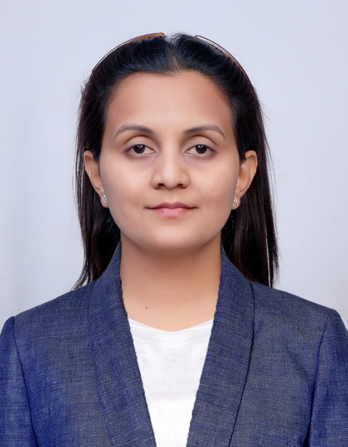
Education: M. Pharm. (2016): Rajarambapu College of Pharmacy, Kasegaon
B. Pharm. (2014): Rajarambapu College of Pharmacy, Kasegaon
Professional Work Experience:
July 2021 to till date: Assistant Professor at Annasaheb Dange College of B Pharmacy, Ashta
Teaching | Research | Industry |  | Total
2.7 | 00 | 03 |  | 5.7
Professional Affiliations: Registered Pharmacist (Registration No. 184549)
Subject Taught: UG- Medicinal Chemistry, Pharmaceutical Organic chemistry, Instrumental method of analysis.
Research Foci: Computational Chemistry, Synthetic Chemistry, Drug conjugates.
Number of Research Projects: - |  |  | Grants Received: -
Number of Publications: 04 |  |  | Resource Person Presentations: -
Patent:
- Synthesis & Anti-microbial activity of 2, 5 disubstituted -1, 3, 4 oxadiazole derivatives.
- A low-cost electrophoresis kit gel for separation of dye.
- The effect of Gravity and centrifugal force on plant development and Fruit Production.
- A Smart Device for Testing the Presence of Heavy Metals Pharmaceutical Formulation.
- Smart Glucose level Monitoring devise.
Selected Publications:
- AS Patil, SK Mohite, AK Mullani, MG Saralaya, SP Desai. Microwave assisted synthesis of Heterocyclic compound and its anticancer activity. Journal of Pharmaceutical Negative Result.2022; 13(4):1092-1099.
- SP Desai. AS Patil.3D QSAR study on substituted 1, 2, 4 triazole derivatives as anticancer agents by kNN MFA approach. Saudi Pharmaceutical Journal.2023; 31 (12), 101836-101840.
- Dr. Mahesh Saralaya, Sachin Sajane, Shailaja Desai, Dr. Yasmin Momin, Ashwini Patil. Larvicidal activity of synthesized silver nano particles from Caccinia Gradis Leaves extract. International Journal of Mosquito Research.2024; 11 (1), 54-61.
- Aishwarya C Patil, Ashwini S Patil, Shailaja P Desai. Noisome: A future of Targeted Drug Delivery Systems as Promising Nano carrier Through Blood-Brain Barrier for Natural Drug Delivery.2022;20(17), 1547 - 1554.
Book Chapters
- Evidence based practice.
- Nuclear medicine technology.

